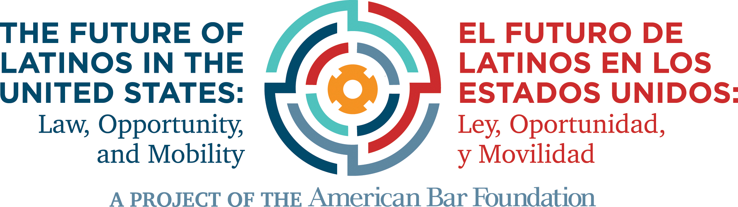

Network for Justice:
Creating Legal and Legislative Support for Latino Communities

Strategic Implementation Plan

Authored by:
---------
Pilar Margarita Hernández Escontrías
Luz Herrera
Rachel Moran
Leticia Saucedo

With collaboration and research assistance from:
---------
Tanairi Alcaraz
Daysi Alonzo
Omar De La Cruz
Robert Nelson
Estephanie Villalpando

Presented to:

The California Bar Foundation

EXECUTIVE SUMMARY

This is a one-year strategic implementation plan for the launch of The Network for Justice: Creating Legal and Legislative Support for Latino Communities, a project of The American Bar Foundation (ABF). The Network for Justice is a part of a broader ABF research initiative entitled “The Future of Latinos in the United States: Law, Opportunity, and Mobility.” We propose to launch a pilot network that will transform Latino civil rights through sustained networking and collaboration among community organizations, the practicing bar, scholars, and law schools in California. Once this Network is launched in California, we hope to expand it to become a nationwide effort.

In the Introduction, we detail how a Network for Latinos can address the legal, social, and political needs of Latinos residing in the United States. By 2050, the U.S. Census Bureau estimates that whites will no longer constitute a majority in the United States. While the White population will account for 46% of Americans, Latinos will make up 30%. However, as we detail in this section, California is already leading the nation in Latino growth, with 39% of the total population identifying as Latino. This demographic profile, as well as the strength of California’s infrastructure of support for Latinos, makes it the perfect site for a pilot project. We end the section with a statement of our values and an overview of the long-term Core Strategic Goals for this initiative.

In our section on Challenges and Opportunities, we discuss how the dramatic demographic shift in the nation’s overall racial and ethnic composition will present challenges to fulfilling the promise of equal justice for Latinos, as well as how it can offer unique opportunities to draw from resources already available. These resources include the strength of the Latino activist community, including DREAMers and Immigrants’ rights folks, the cadre of activist scholars who are present throughout the university systems, and the role that innovative technology can serve to serve as the link between these communities.

Following this background information, we discuss each of our Core Strategic Goals and associated objectives, providing overviews, timelines, and budgets for each.

Core Strategic Goal #1 is focused on the infrastructure and relationship-building aspect of the project to create a Network for Justice. Objective 1.1. involves the creation of an online repository of Latino-serving organizations, pro-bono attorneys, research institutes investigating issues of importance to Latinos, law school clinics, and foundations that fund Latino issues. Objective 1.2 builds from this repository in linking key actors together through yearly conferences, quarterly e-mail updates, and educational webinars.

Core Strategic Goal #2 is centered on relationship-building with legislators, policy makers, and institutes of public policy. Objective 2.1 will involve building on established relationships with the California Latino Legislative Caucus. Objective 2.2 will focus on building collaborative networks with public policy schools in California by developing a research fund for scholars.

Core Strategic Goal #3 is concerned with leadership development. Objective 3.1 involves the collection and compilation of existing leadership programs that promote leadership development in academia, law and policy, community organizing, and entrepreneurship or wealth creation. Objective 3.2 encourages knowledge-sharing among academics to exchange curricular models, including syllabi, teaching materials, and training models that promote leadership development in Latino communities. Objective 3.3 entails the procurement of funds to establish mid-career and post-graduate fellowships for lawyers, policy makers and researchers, and research assistant positions for students pursuing work that serves the Latino community, either through direct legal service or scholarship.

The goal of the Network for Justice is to facilitate and support local and statewide efforts to connect community advocates to formal channels of creating law and policy. The strategic plan for implementation provides a roadmap for the California network. It focuses on existing institutions and does not anticipate the formation of a new entity because we believe the building blocks for the infrastructure to support law and policy that advances Latino interests is already in place but needs to be better connected. The largest need for resources exists in the state’s rural communities where Latinos comprise large sectors of the population. In these communities, community engagement strategies and integrating technology to connect them to existing centers may be critical to building a network. We look forward to working with existing organizations and institutions to collectively take on some of these efforts to build an effective Network for Justice that helps promote better law and policy for California and the nation.

INTRODUCTION
The Future of Latinos in the United States Overview

The American Bar Foundation’s (ABF) mission is to serve the legal profession, the public, and the academy through empirical research, publications, and programs that advance justice and the understanding of law and its impact on society. As the nation’s leading research institute for the empirical study of law, the ABF has operated as an independent, nonprofit organization, for sixty years, and has advanced the understanding and improvement of law through research projects of unmatched scale and quality on the most pressing issues facing the legal system in the United States and the world. The ABF is committed to broad dissemination of its research findings to the organized bar, scholars, and the public.

One of the ABF’s initiatives is “The Future of Latinos in the United States: Law, Opportunity, and Mobility.” This project is a nation-wide, interdisciplinary research initiative that is devoted to producing innovative scholarship on the Latino population in the United States and locating the sites of intervention that promise to be most impactful in promoting opportunity through law and policy.

This broader project has three pillars: 1) research; 2) teaching; and 3) outreach and dissemination. In each of these areas, we expect to build networks to enhance communication, cooperation, and collaboration as scholars, activists, and policymakers plan for incorporation of the growing Latino community at the regional and national level. The research strategy includes hosting regional roundtables and a national summit that bring together scholars from law and other disciplines with policymakers, attorneys from legal advocacy groups, representatives of community organizations, media experts, and foundation officials. The roundtables enable different stakeholders to collaborate in imagining the future by using a method that is forward-looking and does not privilege a particular discipline or occupation.

Based on community input, the ABF’s project on the Future of Latinos centers its research and advocacy projects around four law and policy areas that we have identified as crucial levers of change: 1) immigration; 2) political participation; 3) education; and 4) economic opportunity. All of our project roundtables focus on these policy concerns as orienting frameworks for discussion. Although we will not limit the work of our network exclusively to exploring these four policy areas, the Network for Justice will use these four broader themes as points of departure for our advocacy goals.

A Network for Justice

The Network for Justice: Creating Legal and Legislative Support for Latino Communities is one arm of this project and it seeks to transform Latino civil rights through sustained networking and collaboration among community organizations, the practicing bar, scholars, and law schools. Our research found significant underrepresentation of Latinos and their advocates in legal matters of great significance to their future prospects. We believe there is an urgent need for an initiative that helps bridge the access to justice gap for Latinos. The idea for the Network for Justice was inspired by the role that Howard Law School played in producing and supporting lawyers who advanced law and policy to promote the integration and inclusion of African Americans. However, there is no equivalent of Howard for Latinos today. The Network for Justice, therefore seeks to build on existing community assets such as interdisciplinary research programs, law school clinics, existing initiatives by legal services providers, leadership development programs, and innovative technology to address the growing legal needs the Latino community more effectively.

This network will be especially crucial in reaching underserved populations in counties where the state’s Latino population has increased, but where there are fewer resources for the growing numbers of Latinos. In the past 30 years, the curtailing of federal funding for the poor and restrictions on how those funds can be spent have greatly impacted all Latinos, not just the large undocumented population that is restricted from receiving federally funded legal services.

The Need for a Network

By 2050, the U.S. Census Bureau estimates that whites will no longer constitute a majority in the United States. While the White population will account for 46% of Americans, Latinos will make up 30%; African Americans, 12%; and Asian Americans, 8%. This dramatic demographic shift in the nation’s overall racial and ethnic composition is unparalleled in many ways, making full integration and inclusion of previously underrepresented groups more imperative than ever. Latinos in particular are no longer a small or regionally concentrated population. Latinos now reside in every state in our nation and, in some communities, comprise a majority of the population.

Despite these significant population shifts, Latinos are still largely invisible in public life and are substantially underrepresented in law, legal education, and leadership circles. This lack of representation is significant because how and whether this community engages in our democracy will contribute to the definition of justice in the United States. Today, Latinos lag behind in significant areas such as education and economic attainment. Nationwide, Latinos have experienced high levels of inequality, losing an astounding 40% of their wealth during the Great Recession. Unlike Whites, their net worth has continued to spiral downward. Approximately one-quarter of Latinos live in poverty.

Latinos’ median household income is approximately $51,400 but it is $38,000 for the largest Latino subgroup of Mexican origin. In July 2014, the Washington Post reported that Latinos held only 2.2% of the U.S. wealth. The Bureau of Labor Statistics reported that in the last quarter of 2016, the median income for Latinos who worked full-time was $646 per week, compared to $675 for Blacks, $881 for Whites and $1,022 for Asians. Further, Latinos – documented and undocumented – are often the victims of employment discrimination and wage theft at higher rates than white laborers. According to a study by the UCLA Institute for Research on Labor and Employment and the Center on Urban Economic Development, foreign-born Latinos are the group who suffer from the highest rates of wage theft and minimum wage violations. Compounding this economic marginality are language barriers experienced by the 19% of the Latino population that primarily speaks Spanish. Taken together, these obstacles often translate into a lack of access to law and justice. Latinos who make $16 an hour or less find it difficult to navigate a legal system with limited free legal resources and attorney rates that are at best ten times their hourly rate.

The lack of access to the legal system has serious consequences. For example, a 2014 report released by The Columbia Law School Human Rights Institute documents many of these inequalities, particularly as they related to immigration proceedings. As the report notes, “although federal law provides that defendants in immigration removal proceedings may not be denied the opportunity to be represented by retained counsel, there is no statute directing the federal government to pay for counsel in these cases…” Because Latinos and other communities of color experience levels of poverty at higher rates than whites, this becomes especially burdensome for people and families who find themselves entrenched in an arcane and cumbersome immigration system.

These issues of legal representation are further complicated when we consider that in 2010 the Census reported that only 5% of all lawyers in the country are Latino. As of 2014, only 7.9% of law school graduates nationwide are Latinos. According to a Congressional Research Service Report, there are 66 Latino U.S. District Court Judges (9.7% of total) and 14 Latino U.S. Circuit Court Judges as of 2016 (7.8% of total). There are many reasons for this lack of Latino representation in the legal profession. Maria Chávez, in her study of Latino lawyers in the state of Washington, cites that 55% of Latino lawyers and 66.7% of Latina lawyers felt that they faced personal family obstacles in obtaining a law school education, with 23.3% of Latinos and 26.2% of Latina respondents noting that the family obstacles were “substantial.” This is in comparison to only 8.4% of non-Latino male lawyers who felt that they faced substantial obstacles to pursuing a legal career. The data Chávez collected demonstrate that Latinas and Latinos face pressures that their white counterparts do not throughout the undergraduate and law school experience.

When it comes to Latina and Latino elected officials, the numbers are equally disappointing. As of January 2015, the National Association for Latino Elected Officials reported there were 302 Latinos serving in the state legislatures of 38 states, with 73 serving in State Senates and 229 serving in state lower houses. Given that there are 7,383 state legislators in the United States, the overall percentage of Latina/o legislators hovers at 4%. The low numbers in both the legal profession and elected office have profound implications for the broader Latino population and the closing of the access to justice gap.

Although the Latino population is significant, the level of engagement with these issues by scholars, lawyers, and leaders is low. Much of the anti-Latino rhetoric that surrounded the 2017 Presidential campaign and the lack of structural responses to those attacks is just one indication of the lack of infrastructure to support laws, policies, and media stories that positively affect the Latino community. While immigrants compose 12.9% of the U.S. Latino population, 63% of Latinos are not foreign-born as of 2012. Large percentages of Latinos, whether immigrant, U.S. citizens, or not, continue to confront obstacles to fair wages, adequate housing, educational opportunities, and economic mobility.

While there are national organizations that support Latino social service delivery, civil rights litigation, and policy, there is currently neither a state-based nor a national network that connects scholars, community organizations, law school clinics, and policy-makers to assist Latinos with law and policy matters. A commitment to service on behalf of lawyers, scholars, and educators will be even more crucial in the years to come, as working class individuals lose social safety nets, as LGBTQ communities see their civil liberties suppressed, and as immigrants are inhumanely detained and deported.

Such organizations as the Legal Services Corporation, which has helped secure justice for millions of people, including low-income clients, seniors, and the disabled may be abolished or severely underfunded with the current presidential administration. As we look toward a future in which legal services are under attack, it is even more critical to develop a plan to assist underserved communities. The ABF is committed to generate findings that can be utilized by organizations and individuals who work to advance justice for the Latino community.

The legal needs and priorities of the Latino community vary based on the specific demographic characteristics, assets and networks of each region. Regions with emerging Latino communities who are primarily low-income and immigrant may not have as many community organizations, elected officials, or financial support to launch projects that engage different types of constituencies required to build an infrastructure to support their law and policy goals. For this reason, the Network for Justice is developing a pilot project to help identify principles that each community can use to guide its development of best practices that address their specific need. This Network for Justice must be built through thoughtful community engagement strategies that incorporate the ideas and work of those whose rights it seeks to advance. Recognizing the structural inequalities that exist in various communities, we decided to focus the pilot of our first Network for Justice initiative in California.

The present Strategic Implementation Plan details our goals for launching a Network for Justice in California. We envision this Network for Justice ultimately being national in scope; however, we selected California to launch a pilot project given that California is already experiencing the demographic shift we anticipate for the nation. Further, it has an organizational infrastructure that is unparalleled, and California already has a significant number of representatives in the state legislature who are advocating for Latino interests. A successful Network for Justice in California can serve as a model for other regional networks across the nation.

The California Pilot Program: A Demographic Snapshot

California’s demographic profile represents the future of the United States. Latinos now comprise 39% of the total population in California, already exceeding the 30% estimate of Latinos’ share of the nation’s population in 2050. Demographers predict that by 2060, Latinos will make up just under half of California’s population. In metropolitan cities such as Los Angeles, Latinos are already the majority of the city’s population.

California has three of the ten most populous cities in the country, and Latinos play a prominent role in each. Los Angeles is the second largest city in the country but has the largest Latino population nationally. Over 40% of the population of Los Angeles has Latino ancestry. The city of San Jose is the tenth largest U.S. city and 33.2% of its population is Latino. In San Diego, the population of Latinos was calculated at 28.8% in 2010 and its location just north of the busiest international border between the U.S. and Mexico makes it an important city for Latinos, particularly those of Mexican decent.

The demographic shift is not limited to urban centers. In rural counties of California, such as Imperial County, 82.7% of the population is already Latino. As we detail in Table 1 (page 7), eight of the top ten counties in California with the highest overall percentage of the Latino population are located in the Central region. All of these counties with majority Latino inhabitants are situated in high agricultural-yield locations. Imperial County is a leader in exporting commodities worldwide and boasts 489,137 acres of farmable acres. Despite this agricultural prominence, Imperial Valley unemployment rates generally hover at around 20%, and working conditions for farmworkers have historically been deplorable.

Already home to the largest percentages of Latinos, the Central region also experienced the largest increase in the Latino population, with a 2.43% rate of growth, which mirrors the overall rate in the region of 2.78%. The counties in the state that experienced the highest Latino percentage growth are primarily or historically rural. Solano, Merced, Riverside, Glenn, Tehama, and Ventura represent those counties that have witnessed above-average growth in the last five years. Merced County leads the group with an overall growth of 3.3% in the Latino population from 2010-2015. These growth patterns are significant because they reflect the counties and regions with the least-developed infrastructure to support Latino communities.

In the midst of this population boom, significant inequalities persist. For example, 60% of Latino children in California are born into poverty or near-poverty. California Latinas are hardest-hit by gendered inequality, making 43 cents to the dollar as compared to white non-Latino men throughout the United States. These challenges are daunting, but California is uniquely situated to combat these structural inequalities through a sustained and collaborative effort among the many organizations, institutions, and individuals who already advocate on behalf of Latinos.

Table 1
Counties: Highest Overall Percentage of Latino Population

County | Region | Overall Percentage of Latino Population (as of July 1, 2015)
Kern | Central | 52.2%
Fresno | Central | 52.4%
Kings | Central | 53.6%
Madera | Central | 56.7%
Monterey | Central | 57.8%
Merced | Central | 58.2%
Colusa | North Central | 58.5%
San Benito | Central | 58.7%
Tulare | Central | 63.6%
Imperial | Inland Desert | 82.7%

There are other states such as New Mexico and counties in Texas and Florida that already have Latino majorities. However, California was chosen to launch the pilot project because of its substantial organizational infrastructure to support Latinos. As part of our broader project, we have mapped 68 Latino organizations and centers in California that serve Latinos. The vast majority of these organizations operate in urban areas (see Figure 1, next page). While these data are not exhaustive, they nonetheless show that there is a severe lack of service to Latinos in rural communities, particularly in the Central and Northern regions. These are areas that are heavily agricultural and that rely on immigrant labor. They also reflect the regions where there are many documented injustices against migrant farmworkers.

Even when Latino-serving organizations can be found in these more rural areas, there are not many that provide legal services. For example, Farmworker Justice recently released a “Directory of Organizations that Serve Rural Latino Communities.” Of the 51 Latino-serving organizations included in this directory, 47 (or 92%) are health-related service providers and only 1 of the 51 organizations specifically targets Latinos (The National Latino Research Center at CSU San Marcos). There is a real lack of legal assistance providers, with California Rural Legal Assistance (CRLA) being the only organization in these counties that consistently offers such services to the growing numbers of farmworkers in California’s central region. Despite the crucial role that CRLA played in providing legal services to this underserved rural population, it is perhaps the legal aid organization that has been most scrutinized by the federal government for its work.
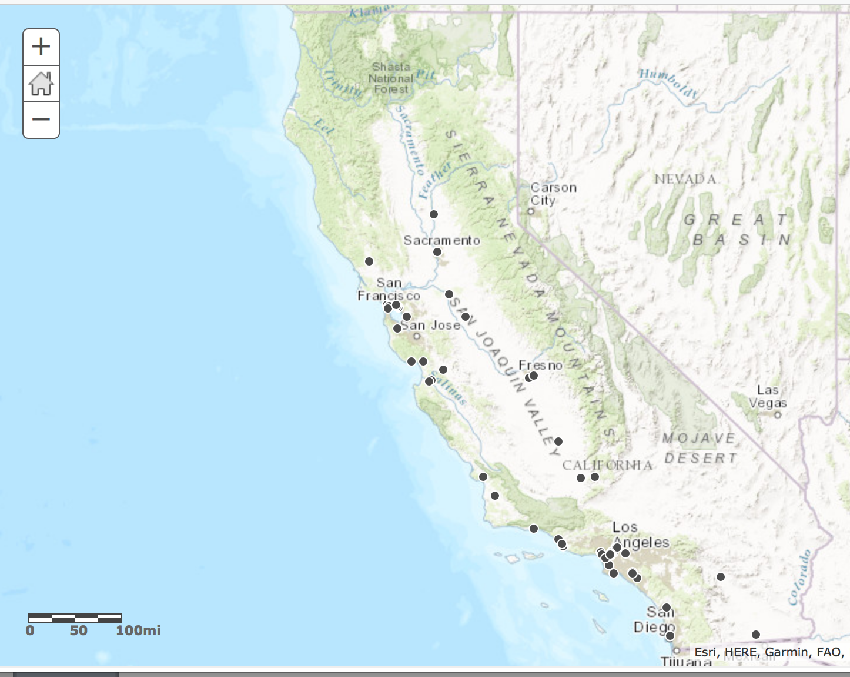

Figure 1: Map of Latino-Serving Organizations in California

In addition to the large population and significant organizational infrastructure, the state also has a notable number of state legislators who advance legislation responsive to the needs of the growing Latino population in California. The California Latino Legislative Caucus (“Caucus”), comprised of 29 members, maintains an active and engaged presence in the legislature, developing policy goals, convening policy discussions, and developing, sponsoring and advocating for legislation that improves the lives of Latinos in California. The Caucus also supports its members who are in legislative leadership positions. The Caucus has seven public policy priority areas, all of which dovetail with the priorities of the Network for Justice. These include policy initiatives related to economic development, immigration, education, civic engagement, health care, energy and water.

To that end, the Caucus initiates and supports research and has issued reports on issues such as unaccompanied immigrant minors, immigrant contributions to the California economy, the state of elderly Latinos in California, immigration reform, and the state of farmworkers in California, along with general reports on the state of Latinos in the state.

Over the past four years, the Caucus has sponsored over 30 pieces of legislation that directly affect the Latino community. The issues raised in these bills range from immigration to energy to labor protections for farmworkers, from K-12 ethnic studies to financial assistance for higher education, and from drivers’ license regulation for immigrants to protection of voting rights for underrepresented minorities.

Because of the various opportunities and challenges present in the State of California, the Network has initially focused this strategic plan on the development of a California Pilot Program. The strategic plan offers a vision for a network that will help to address the legal issues that disproportionately affect Latinos in the state.

We begin this strategic plan by highlighting our values and then describe each of our three Core Strategic Goals, detailing the specific priorities and strategies for achievement. For each of the individual objectives, we also include a timeline action plan and a budget to begin development of the Network and implementation of its work. We then turn to a discussion of tools that we wish to utilize to implement of the Network for Justice. Before concluding we also anticipate factors affecting successful implementation of our Network for Justice California Pilot Program.

Our Values

As individuals and as a broader initiative, we operate under four basic guiding principles.

First, we maintain a deep desire to serve the Latino community. As members of the Latino community, project principals have an intimate understanding of the difficulties Latinos face when attempting to seek legal assistance. As a result, we hold a personal commitment of service to our community. This approach also means that we will work directly with communities in establishing network goals rather than impose our own views upon communities in need, which would only serve to replicate systems of marginalization that often exist in the service sector.

Second, building from our own experiences, we believe that any present effort to support the Latino community must also serve as a foundation to prepare the next generation of leaders. We are committed to mentoring emerging Latino leaders by working with university centers and law schools to develop opportunities that expose more Latino students and advocates to leadership opportunities that positively impact the Latino community. Part of this effort includes collaborating with network participants to establish fellowships and internship placements, in addition to research assistant positions.

Third, the Network for Justice respects the fact that local actors already have networks. Rather than ignore their existence, we seek to draw and build on local knowledge to avoid duplicating efforts. The planning summit revealed that there are already strong networks in the areas of immigration law and workers rights issues but that other areas of collaborative advocacy remain largely untapped. While this network recognizes the importance of organizational leadership inclusion, we also believe that community members must have a voice. For this reason, as we detail throughout this strategic plan, the network must incorporate community input and engagement through surveys, interviews, town hall meetings, and other methods of outreach facilitated through technology. Input from community organizations with history of working on these issues will be particularly relevant to the success of this project. Ideas for community engagement are included below in the goal implementation timelines for the pilot project.

Finally, we are dedicated to collaborating across sectors through the establishment and co-curation of this network. By using the term “co-curation,” we mean the active incorporation of multiple voices throughout the creation process. It is therefore a process, not a product, which involves co-creation, co-production, and co-responsibility. As such, it must necessarily involve input by various stakeholders, many of whom may have competing agendas.

Figure 2: Schematic of Our Values

Core Strategic Goals

This Network will build on existing infrastructure to advance the following overall long-term strategic goals:

- Build Community Resources: There has been widespread recognition of a gap in access to justice in America. Because of disparities in characteristics such as education, income, wealth, citizenship status, and language proficiency, Latinos find it difficult to obtain legal representation. By creating a network of organizations, law schools, and advocates around the country that build ongoing relationships with organizations that advocate on behalf of Latinos, we anticipate that these interests will be more systematically represented in courts, administrative agencies, legislative bodies, and law schools.

- Establish Policy Partnerships: Presently there is little collaboration between academic researchers and legislators. Operating under the guiding principle that research must be relevant in the advancement of social good, we are committed to ensuring that any research or data we generate will be shared with policy makers. Similarly, we are committed to creating more opportunities for academics and policy-makers to work together to implement policies that promote equity and access not only for Latinos but for the larger population. This initiative is particularly important because the California Latino Legislative Caucus has already defined policy priorities based on constituent needs.

- Coordinate Leadership Development: While state legislatures have seen significant increases, the population growth calls for greater leadership development of Latinos to be architects, guardians, and defenders of equitable law and policy. The Network for Justice’s leadership development program would support a pipeline of leadership for the next generation of lawyers, policy makers, and community organizers who can facilitate legal services and representation for the Latino community in a sustained, culturally competent way.

The opportunities and resources afforded by our network should encourage law schools to establish new programmatic offerings that elevate the quality of legal education and provide additional training opportunities that create more advocates for Latino issues. We hope this will encourage young Latinos to enter the legal profession in greater numbers. This advancement of knowledge and diversification of law students will produce a practicing bar that can better serve all clients, but will be specifically aware of issues that impact Latinos.

In the long run, this mentoring and training can help to mitigate the serious access to justice gap for Latinos. For example, we believe that students who participate in a law school clinic that is committed to addressing Latino concerns will become more aware of the organizations that are advocating in this area, the legal trends that are emerging, and the strategies that are being brought to bear to address the need for reform. When these students graduate, they should have greater knowledge, skills, and inclination to advance the representation of Latinos’ interests.

Figure 3: Schematic of Core Strategic Goals

OPPORTUNITIES & CHALLENGES: Factors Affecting Implementation
Challenges

Funding

Given that the current national political climate is fairly hostile to immigrants and Latinos, universities and other allies relying on public dollars may be hesitant to pursue research that may be perceived as promoting Latino advocacy. In a 2010 study of clinical professors, for example, researchers found that 1/3 of all respondents are concerned that funding will be stripped if their clinical work is deemed “too political.” Similarly, federally funded legal aid programs have extensive restrictions on providing legal services to undocumented persons. Funding for the non-profit sector is also contingent upon the goals of any given government administration or foundation leadership.

For this reason, it is imperative to establish a network that can, to the extent possible, operate independently of political restrictions. We believe this initiative can help us think beyond traditional funders to seek new allies and to help network participants think about how to sustain their own work through entrepreneurial efforts. In addition to encouraging more introspection about the economic power of Latinos in California, we believe this network can help us bring to light the need for greater cultivation of individual Latino donors and improve the scorecard for foundation resources to Latino communities.

Lack of Collaboration

Although California is home to a rich diversity of service providers, law schools, and research centers, there currently is a relative lack of collaborative relationships. While individuals may cooperate across organizations and institutions, these collaborations are rarely, in fact, institutional. Resources and funds are not often shared among constituencies, and research generated by centers and law schools usually remains isolated from the public. As a result, direct service providers sometimes express a justifiable hesitancy to collaborate with academics who do not maintain established ties to affected communities. Finally, participants at our roundtable conceded that one particular area where coalition building may be necessary is between providers located in big cities and under-served rural communities.

Opportunities

The task of building a Network for Justice can seem daunting. However, because California is in many senses, resource-rich, we plan to integrate important state resources in our plan of implementation. These include:

Activist Scholars

California is home to two state university systems as well as numerous private research universities that include public policy schools, law schools, business schools, and a variety of social science departments engaged in scholarship that has a community impact. This Network for Justice offers the opportunity to identify and connect the activist scholars in these various institutions to share their research with each other and collaborate with community organizations to engage in research that advance law and policy for Latinos in the areas of immigration, political mobilization, education, and economic opportunity.

Consumer Power

Latino purchasing power is growing at a higher rate than the total population based on its demographic growth. Purchasing power is the financial ability to buy products and services. In its annual report on the Minority Economy, the Selig Center for Economic Growth at the University of Georgia, Athens found that in 2016, Latinos in the U.S had a purchasing power of $1.4 trillion – a larger amount than the gross domestic product of Mexico. The purchasing power of U.S. Latinos is larger than all but 14 countries in the world and is expected to grow to $1.7 trillion by 2020.

Dreamers & Immigrants Rights Movement

California is home to several organizations that service the active and strong DREAMER/Immigrant Rights movement, including the National Immigration Law Center, Educators 4 Fair Consideration, Asian Americans Advancing Justice, Immigrant Legal Resource Center, and Grantmakers Concerned with Immigrants and Refugees. In addition, the University of California has invested in providing legal services for its undocumented students through the UC Immigrant Student Legal Services Center. Each of these organizations provides invaluable expertise in the form of know-your-rights information and trainings, in-depth immigration law analysis, organizing and mobilization, and funding resources. In this era of executive and congressional targeting of immigrants based on race, religion and national origin, the Network for Justice can and will play an important role in developing messages, materials, and information that speak to the Latino experience. This strong immigrant rights movement and immigration network serves as an important model to build on to promote other topics of interest for Latinos.

Internet Advocacy

A core technology that will be crucial in developing this network is the internet. We now live in an age in which advocacy is not only carried out in the streets or in the courts, but also through online portals. Social media and online organizing have become core approaches to activism, with black, Muslim, and Latino communities in particular turning to such platforms as Twitter, Facebook, and Instagram in larger numbers. These online platforms provide underrepresented communities with a voice in an effort to expose daily injustices and organize coalitions around a particular cause. #ArabSpring, #BlackLivesMatter, #HereToStay, and #Not1More are some examples of how national and international grassroots movements can be built in large part through cyberactivism and internet advocacy.

In California, 95% of all households have access to Wireline Broadband Internet. While a digital divide certainly exists in the state, with only 42.9% of rural households served, the potential success of an online network nonetheless remains promising. Many Latinos access the internet through their phones and, as the Pew Research Center finds, by 2015 84% of Latinos nationwide reported internet use, with a lower percentage of Latino immigrants doing the same (78%). This reflects a 20 percentage point increase in the last six years. Internet advocacy will be crucial not only in outreach but can also be incredibly relevant in increasing legal service delivery to the Latino population in underserved rural and blighted urban communities.

Labor Movement History

Organized labor campaigns that improve wages, working conditions, and tax resources to support public education and other services have a successful history in California. Since Latinos comprise a large portion of the working class and immigrant population in California, Latinos have been central to worker rights campaigns and initiatives that encourage higher voter turn out of low and modest income voters. From rural campaigns led by the United Farm Workers to SEIU’s Justice for Janitors campaign, Latinos have been central to improving the working lives of workers in California. The most recent victory to increase the state minimum wage of $10 to a living wage of $15, is just an example of a campaign where Latinos were central in advocating for a policy change that benefited all California workers.

Law Firm Pro Bono

There is already an abundant network of law firms contributing pro bono services to community and legal aid organizations, clinical programs, families, and individuals. The Network for Justice will continue to work with partner organizations who already collaborate with such law firms and seek to engage lawyers and law firms that are not already engaged in pro bono activities to consider providing their time or financial resources to support direct legal services, policy development, and impact litigation priorities identified by the Network. In addition to traditional pro bono models primarily driven by large law firm, there are new pro bono models that involve technology and community-based practitioners that will continue to be studied and considered as potential models for pro bono collaboration through the Network.

Online Delivery of Legal Services

In the last twenty years, technology and more flexible ethical rules have transformed the delivery of personal legal services delivery from full-scope representation to limited scope representation. Limited scope representation permits a client to hire a lawyer to handle part of the legal matter that she is facing. Courts and other bodies that seek to address large gaps in the public’s access to the legal system have been key players in promoting limited scope representation, or unbundling of legal services. Limited scope representation for personal legal services permits legal services consumers to find court forms on websites, complete them and hire an attorney to review the forms and advise them before filing in court. The public can now access forms and consult attorneys for advice online or by phone.

Although, it is not a substitute to full representation, unbundling of legal services creates access for individuals who would not otherwise hire a lawyer. The type of partnership that unbundling facilitates allows clients to reduce the cost of their legal representation by either doing some parts themselves or finding lower cost alternatives to lawyers who can help them navigate legal services. Limited scope representation exists in many sectors of the legal profession but is primarily relevant to Latinos in the delivery of personal legal services in the areas of family law, real estate and housing, consumer law, immigration, and a variety of other civil matters.

This new way of providing legal services and the ability for clients to control the solution to their legal matter is an important development in the law but one that the Latino community has not fully utilized to address its legal needs. There are few examples of Latino lawyers and clients who optimize online delivery of legal services even in the field of immigration – an area of law that has seen a number of dedicated online platforms. While online delivery of legal services is not the only or the best solution for many legal problems, it does expand the accessibility of lawyers to individuals who may be financially unable to hire an attorney to take on an entire case. There is an opportunity for the Network for Justice to convene lawyers, computer scientists and entrepreneurs to develop online platforms and applications that facilitate legal services delivery to the Latino community.

Planning Summit

On November 7, 2016, we convened over 40 non-profit leaders, politicians, law school professors and representatives, foundation officials, and emerging leaders at UCLA Luskin Center to brainstorm ways we can build a collaborative partnership among communities serving Latinos. The main objective for the planning summit was to identify the necessary components for a successful Network for Justice pilot program in California. Among the participants were California Supreme Court Justice Mariano-Florentino Cuellar, California Assembly Members Lorena Gonzalez, and Jose Medina, President and General Counsel of the Mexican American Legal Defense Educational Fund Thomas Saenz, California Rural Legal Assistance’s Executive Director Jose Padilla, President and Chief Executive Officer of the California Community Foundation Antonia Hernandez, California Bar Foundation Executive Director Sonia Gonzales, and Dean of the UC Davis School of Law Kevin Johnson.

Prior to the convening we prepared background materials for the participants and began the day-long summit with an overview of the “Future of Latinos” project as well as a description of our goals for the Network and for the proceedings. After the opening remarks, we convened two panels comprised of summit participants who described their sense of the greatest challenges in bridging the access to justice gap for Latinos. They identified ways that successful models of collaboration might address these challenges. We then had a breakout session comprised of small, mixed-stakeholder groups to discuss further the challenges faced in providing services for Latinos. The groups discussed the greatest opportunities for change, identified existing partnerships, and began to brainstorm the necessary components of a successful network. We ended the day with a moderated discussion led by Manny Medrano. This discussion outlined how the establishment of a Network for Justice could build on existing strengths and provide opportunities for improvement.

Many discussions revolved around the lack of a centralized body that can maintain networks of knowledge and communication. Participants acknowledged that this is in part due to the diverse nature of direct service, where rural service providers often lack the financial and staff resources to participate in a sustainable network. In addition, scholars and lawyers interested in advancing these initiatives have a number of competing interests and institutional priorities. For this reason, it is important for us to focus on just a handful of well-defined goals with measurable outcomes.

The three core strategic goals outlined above are discussed in greater detail below. After an overview of each goal, we discuss the need the goal addresses, the strategies to achieve the goal, a year-long timeline for launching the goal, and an estimated budget. This strategic plan is written to permit different stakeholders to provide leadership in moving forward with the Network for Justice and also envisions a centralized administrative body to coordinate with the various collaborators.

CORE STRATEGIC GOAL #1: Community Resource Building

Core Strategic Goal Overview

Core Strategic Goal #1 is focused on the infrastructure and relationship-building aspect of the project to create a Network for Justice. As we detail below, Objective 1.1. involves the creation of an online repository of Latino-serving organizations, pro-bono attorneys, research institutes investigating issues of importance to Latinos, law school clinics, and foundations that fund Latino issues. Objective 1.2 builds from this repository in linking key actors together through yearly conferences, quarterly e-mail updates, and educational webinars. We believe that an ongoing collaboration among the key stakeholders is a crucial part of any online community-building effort.

As we embark on uncertain times in these next few years, it will become even more crucial for Latino-serving organizations and advocates to build coalitions with one another and with leaders from other marginalized and targeted communities. We maintain that by building this infrastructure of Latino advocates and practitioners and establishing a strong and connected coalition, we will be in a better position to work more effectively.

Figure 4: Schematic of Core Strategic Goal #1

OBJECTIVE 1.1: Online Repository and Identifying Agents of Change

Objective 1.1 Overview

The Network for Justice will address the crucial need to build and maintain resources of relevance to Latinos as well as to the constituencies that will comprise the Network. To that end, we intend to develop a repository of organizations, institutes, and law school clinics in California, as well as identify the primary agents of change. This repository will be presented in the form of a searchable map-based database.

Need for Objective 1.1

Currently there are a few organizations that maintain lists of Latino-serving organizations across the United States. Most notably, the National Council of La Raza (NCLR) publishes a list of affiliate organizations numbering 260 nationwide. The Immigration Advocates Network likewise includes a legal services directory on its website.

These lists are valuable resources for the present project, but our Network goes beyond compiling information on organizations in California that serve Latinos. In addition to including searchable maps online, we will include research institutes, scholars, and attorneys in our network and provide advocacy resources as well as bilingual resources for teaching.

Preparedness in Implementing Objective 1.1

We have already begun inventorying law schools and law school clinics, research institutes, and Latino-serving organizations across California. So far, we have input 84 ABA-accredited law school clinical programs, 27 research institutes, and 69 Latino-serving organizations into our project database. You can see an example of these heat concentration maps in Figure 5 (page 19).

Utilizing the program ArcGIS (geographic information system), we created an interactive map with descriptions and contact information that can be easily navigated. Figure 6 (page 19) shows how the information on each organization can be captured and spatially organized using ArcGIS.

Strategies for Achieving Objective 1.1

This objective is relatively straightforward to accomplish. It requires funding to:
- hire a student research assistant who can continue the research already begun by project principals and to upload all content onto a password-secure website; and
- hire a project manager to coordinate meetings of project principals and research assistants, to update the website monthly, and to implement suggestions from Network members, including initiating policy briefs or appellate case briefs.

We view the maps as living documents, and we hope that individuals and organizations suggest additions to the maps so that this is truly a collaborative community effort. In order to accomplish this goal, the website will operate from an open-source model that facilitates collaboration and co-production/co-curation. Members of the network will submit information to the project manager and the American Bar Foundation will serve as the centralizing unit that uploads this information onto the online forum.

We will include an online suggestion portal that allows users to suggest organizations, attorneys, law school clinics, and foundations that can be added to our map. This co-curation of resources will be crucial, especially in making sure that all areas of California are equally represented. It is important to note that all of the data points currently entered into the maps were found through internet searches, so these maps privilege organizations, attorneys, and foundations that have searchable websites. It is likely that there are many non-profit organizations and attorneys, particularly in rural and underserved areas, that do not have the resources to maintain websites. In these instances, we will rely on local community knowledge to input data into our repository.
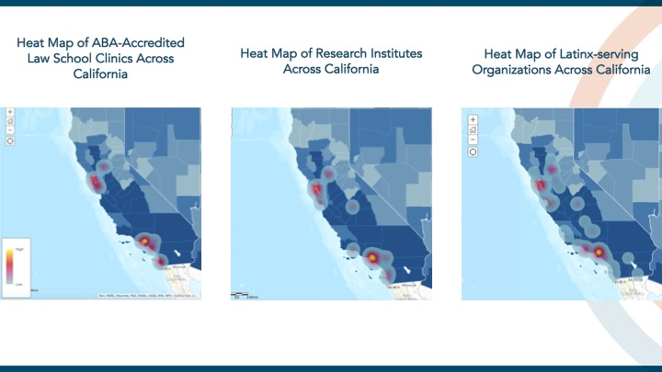
Figure 5 (above): Mapping of Infrastructure

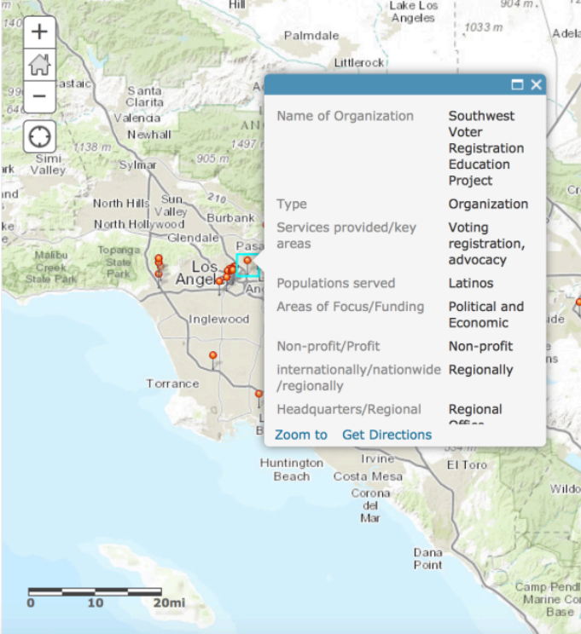
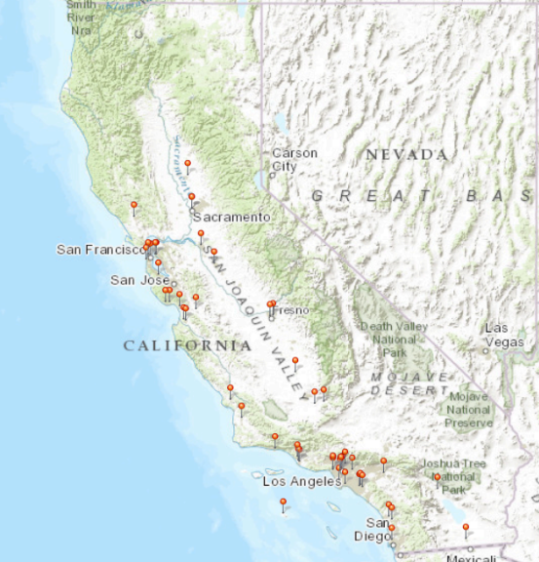

Figure 6 (above): GIS mapping of Latino-serving organizations in California (left); information provided on each location (right).

Timeline: Year 1

Below we detail the month-by-month action items that will help us achieve Objective 1.1 in the first year of the network launch, following submission of this strategic plan.

Month 1 | Research possible funding sources and prepare grant applications in coordination with Mark O’Brien of Pro-Bono Net; incorporate feedback on Objective 1.1. following circulation of strategic plan.
Month 2 | Seek buy-in from pro bono attorneys, lawyers, law professors, and community organizations by presenting at organizational meetings, conferences, and other gatherings were multiple constituencies are present.
Month 3 | Apply for grants to support the launch of the online network.
Month 4 | Recruit and train research assistant. Assess buy-in from pro bono attorneys, lawyers, law professors, and community organizations through a survey instrument that determines the areas and projects of interest or attending their meetings.
Month 5 | Apply for grants to support the launch of the online network. Include funding for community member research. Research assistant to continue research.
Month 6 | Hire research assistant and begin designing website in collaboration with Pro-Bono Net. This is an opportunity to hire a member of the community to help develop their expertise.
Month 7 | Launch online network. Talk with organizations about including a blurb in their newsletters so they know about the resources available.
Months 8-12 | Continue populating website. Engage community organizations through regional gatherings to understand their priorities and needs.

Budget: Year 1

We anticipate that launching a website with associated repositories will cost roughly $25,000. We will seek funding for this project in the summer of 2017 in collaboration with Pro-Bono Net, an online membership site for pro-bono attorneys, legal aid attorneys, law professors, and students.

OBJECTIVE 1.2: Facilitate Relationships

Objective 1.2 Overview

Objective 1.2 is centered on relationship-building among and between constituencies. As mentioned, while relationships certainly already exist among individual social actors, few relationships have been institutionally built across stakeholder organizations. Our initiative will provide a forum for building such relationships.

We identify three major ways in which we can facilitate relationships.

First, we will circulate this strategic plan to summit participants for their feedback following initial drafting. We therefore view this Network as a process, not a product, which involves co-creation, co-production, and co-responsibility from the outset. As such, it must necessarily involve input from various constituencies, many of which may have competing agendas.

Second, we will continue the relationships built during and following our summit in part through an online platform. On this website, we will compile a community calendar, offer webinars, and post volunteer opportunities. In addition, we will establish a Network for Justice Advisory Committee.

Third, we will continue our relationship with Latino-serving community organizations, research institutes, the practicing bar, and law school clinics. Below we detail how we will facilitate these networking collaborations.

Need for Objective 1.2

Those who work on Latino issues in the academy, in pro-bono practice, and in direct service often work in isolation from one another. There is a need for a centralized entity to maintain a hub of information, resources, and contacts that are easily accessible online and facilitate quick and efficient knowledge-sharing. In part through our online interface, as well as through dedicated outreach to and collaboration with Latino-serving entities in California, we will address this current lack of sustained and institutional work across sectors.

Preparedness in Implementing Objective 1.2

As mentioned in the previous section, we have already embarked on the process of identifying key players who can collaborate with us in this network. Following our Network for Justice Summit, we circulated a survey to all participants, soliciting advice on how we might improve the network, as well as asking participants their preferred method of collaboration. Several of the participants mentioned that they would like to assist the principals in authoring the strategic plan. Their names are mentioned on the front page. A few of our summit invitees also agreed to assist by leading research projects and providing internship opportunities to students who participate in the network. Currently plan to collaborate with the UCLA Department of Chicana/o Studies and the UCLA College Division of Social Sciences to create a database of applied researchers who might join our network. We also plan to build relationships with the Luskin School of Public Policy at UCLA where a Latino Policy Center is about to form.

Strategies for Achieving Objective 1.2

Strategic Plan Distribution

In practicing our co-curation paradigm, we recognize and embrace a plurality of voices. Thus, following initial drafting of this strategic plan, we will circulate it to all summit participants for their feedback. We will distribute it by May 15, 2017 and give participants until June 30, 2017 to make suggestions for edits. We will then circulate the final version with summit feedback by August 1, 2017.

Creation of Network for Justice Advisory Committee – California Pilot

Following dissemination of the strategic plan, we will select Network participants to serve as members of a Network for Justice Advisory Committee. This advisory committee will provide strategic direction and leadership throughout the implementation of the initiative.

This council will be comprised of:
- Latino civil rights advocates and activists (2);
- Researchers and scholars (2);
- Law school representatives, including clinic leaders (2);
- Law firm representatives (2);
- Foundation official (2);
- Student representatives or other emerging leaders (2)

We hope to recruit 12 individuals to serve on this advisory committee.

Website Maintenance

Once we have compiled a list of organizations, institutions, and lawyers, we will embark on a sustained effort to begin the process of networking. We will compile a listserv of organizational and institutional leaders and invite them to join our online networking forum, respecting that it is likely that many of them have already developed their own networks of knowledge-sharing.

Once we have recruited 30 Network participants, we will establish an online portal that helps create community by providing:
- Community Calendar: Ask Network participants to submit relevant event information to principals and principals will update and maintain a community calendar.
- Webinars: Invite network participants to host free webinars on Network Website.
- Volunteer Opportunities: Provide organizations and direct-service providers with a forum to share their latest news and volunteer opportunities.
- Policy Briefings & White Papers: Share policy and academic pieces that propose priorities for litigation or policy efforts.
- Legislation & Case Watch: Provide network members with information about legislation, including model legislation for municipalities, and cases that directly impact Latino interests.
- Brief Bank: Collect a variety of briefs that serve as models for future litigation.
- Foundation Scorecard: Maintain a database of foundations in California that fund work related to immigration, political participation, education, and economic opportunity.
- Law School Clinics & Policy Schools Database: Provide a list of law school clinics and public policy schools that accept research projects from legislators and community organizations. Each institution will be asked to upload its criteria for work it seeks to do.
- Pro Bono Partners & Training Site: Use the database to link ongoing training for pro bono attorneys and list names of organizations accepting attorneys as partners to provide pro bono representation.
- Member Media Profiles: Provide individuals who are part of the Network for Justice with the opportunity to develop a media profile that will be used to increase the number of spokespersons who can address issues affecting the Latino community in a culturally sensitive manner.

Constituency Collaboration

Our Network for Justice will provide a vehicle for organizations and attorneys to collaborate on issues of common interest and concern. Immigrant rights advocates have successfully built networks that allow clinicians to connect with policy makers and direct legal service providers through listservs. Such connections have facilitated rapid and organized response from personal legal service providers, impact litigators, community organizers, and policy makers. This is the type of collaboration we seek to develop by facilitating in-person and online meetings of advocates who can form larger coalitions to advocate for immigrant rights, inclusive political participation, better educational opportunities, and greater economic opportunity for the Latino community.

In conducting preparation leading up to the summit, we identified 84 ABA-accredited law school clinics. In this next stage of the research, we will identify the necessary leaders and agents of change at each of these clinical programs, as well as the leaders at organizations and centers across California.

The clinical networking arm of our project is unique in scope and methodology. By incorporating the research and important work of social scientists, law professors, clinicians, organizations, activists, and attorneys across the United States through an interdisciplinary framework, we are connecting practitioners and advocates and clinicians and students to one another, thus bridging the divides that have previously existed. In so doing, we are bringing a fresh approach to legal advocacy that involves a diverse array of stakeholders, each of whom bring their unique knowledge and expertise to the process.

Timeline: Year 1

Below we detail the month-by-month action items that will help us achieve Objective 1.2 in the first year of the Network launch, following submission of this strategic plan.

Month 1 | Send strategic plan to Network for Justice summit participants, members of the California Latino Legislative Caucus, key community leaders who were unable to attend the summit, representatives from law school clinics and public policy programs to gauge interest.
Month 2 | Meet with and identify the 30-50 Network participants; create Network for Justice Advisory Committee. Include a community organizer in the Advisory Committee.
Month 3 | Create a database of 30-50 confirmed Network participants. Develop a welcome newsletter and send a RFP for organizations and individuals to develop content.
Month 4 | Communicate with Network participants and solicit resources; create community calendar; recruit individuals to host webinars.
Month 5 | Send Network newsletter and continue to host seminars.
Month 6 | Continue to update community calendars, volunteer opportunities, and resources.
Month 7 | Schedule a session on Best Practices to Implement Policy Session. Speaker TBD.
Months 8-11 | Continue to update community calendars, volunteer opportunities, and resources.
Month 12 | Organize media appearance and op-ed training for community leaders and activist scholars.

Budget: Year 1

The budget to facilitate relationships is $50,000.

We will need to enlist the aid of research assistants to keep the resources and maps updated regularly. In the first year of this website’s operation, we will hire four students to conduct research and manage website suggestions. Two students will be based in northern California and two in Southern California. At least one of the students will be a graduate student conversant in Geographic Information Services (GIS). There should be at least one law student and one student enrolled in a public policy program. In the first year of the website launch, we will pay the students a stipend of $18 per hour for 10 hours of research per week, which will total $37,440. We are budgeting $40,000 for research costs to anticipate reimbursement for travel-related expenses.

In addition, we will need $10,000 to pay a graphic designer to develop our newsletters and other materials to brand the Network. These funds will also be used to support three regional gatherings to train activist scholars and community activists on best practices for writing editorials, opinions, and other media appearances.

CORE STRATEGIC GOAL #2: Establish Policy Partnerships
Core Strategic Goal Overview

Core Strategic Goal #2 is centered on relationship-building with legislators, policy makers, and institutes of public policy. As we detail below, Objective 2.1 will involve building on established relationships with the California Latino Legislative Caucus. We will provide reports, research findings, and policy recommendations to policy makers in California, as well as present project updates regularly when the Caucus is in session. Objective 2.2 will focus on building collaborative networks with public policy schools in California by developing a research fund for scholars who pursue relevant research projects in the areas of economic development, immigration, education and civic engagement.

Figure 7: Schematic of Core Strategic Goal #2

OBJECTIVE 2.1: Building relationships with legislators

Objective 2.1 Overview

Broadly speaking, we are committed to producing research that is relevant to the Latino community and its advocates. Part of this commitment means that our research agenda will be constructed with an eye to ultimately informing policy discussions and action at the federal, state and local levels.

We want to bring together policy researchers and legislators so that there is sustained communication between constituencies. We plan to work with members of the California Latino Legislative Caucus (CLLC) as well as various other local, municipal, and federal policy makers throughout the state of California. The benefit of working with an established entity in building policy relationships is that the CCLC are at the forefront of major policy debates in California.

Currently, CLLC maintains seven policy priorities: 1) Economic Development; 2) Energy; 3) Immigration; 4) Education; 5) Health Care; 6) Civic Engagement; and 7) Water. The CLLC has initiated legislation in each of these policy areas that affect that lives of Latinos in the state. Examples include legislation providing for overtime for farmworkers, a bill expanding the Cal-Grant program, a bill to develop a public school ethnic studies curriculum, and a gender pay equity bill.

We anticipate working closely with the CLLC in Economic Development, Immigration, Education, and Civic Engagement, as those are the four major policy areas that we investigate as part of our broader research project.

Preparedness in Implementing Objective 2.1

We believe it is important to work closely with policy makers as we produce research and other forms of knowledge. It is for this reason that we invited two members of the California Latino Legislative Caucus to participate in our November 7, 2016 planning summit. Assembly Member Lorena Gonzalez Fletcher (80th Assembly District) and Assembly Member Jose Medina (61st Assembly District) both provided insight into the legislative process, barriers to collaboration, and suggested strategies. The summit discussions confirmed both a need for and a commitment to continued collaboration between the Network and members of the CLCC.

The CLLC already works with research and policy institutes such as the California Immigrant Policy Center, the California Institute for Rural Studies, the California Leadership Institute, the California Research Bureau, and the California Senate Office of Research. Examples of research produced by those entities are housed on the CLLC website. The website includes eight reports of policy importance to the CLLC.

The Network seeks to supplement this policy research with studies and reports that speak uniquely to Latino concerns within the broader policy areas of immigration, education, economic development and civic engagement. To that end, the Network will seek to create initiatives that sponsor the development of policy and white papers that will aid the CLLC in its own policy-making. The Network aims to support the production of two to four policy papers a year that advance the mission of policy makers such as the CLLC.

Strategies for Achieving Objective 2.1

Establish Collaborative Efforts with the CLLC to Develop Priorities for Policy Efforts
The Network’s planning summit commenced the efforts to establish collaborations with Latino legislators in California. The Network will schedule an initial meeting with the CLLC’s membership to discuss a process for ongoing collaboration. The CLLC already collaborates with dozens of nonprofit, policy and advocacy groups throughout the state, as is evident from the list of supporters for CLLC-member legislative efforts.

The Network seeks a unique role among these organizations as the facilitator of research that focuses on Latino concerns. The Network will seek to incentivize the development of research and policy proposals to be disseminated yearly to legislators as part of a formal presentation. At its first meeting with the CLLC, the Network will propose regularly scheduled policy briefings to disseminate the research Network affiliates have produced.

Timeline: Year 1

Below we detail the month-by-month action items that will help us achieve Objective 2.1 in the first year of the network launch, following submission of this strategic plan.

Month 1 | Communicate with legislators and members of the California Latino Legislative Caucus; schedule presentation in Sacramento.
Month 2 | Principals prepare for travel to Sacramento to present project strategic plan.
Month 3 | Principals travel to Sacramento, CA to present project strategic plan and to solicit ideas for avenues of research. Request inclusion of legal issues to be included in members town halls or newsletters, or develop a log of constituent calls documenting the issues they call to request assistance on.
Month 4 | Principals incorporate edits from the California Latino Legislative Caucus.
Month 5 | Network for Justice staff to continue to work with elected officials and staff to prepare a policy partnership plan.
Month 6 | Network for Justice staff to continue to work with elected officials and staff to prepare a policy partnership plan.
Month 7 | Circulate policy partnership plan to network summit participants. Include community engagement strategies.
Months 8-12 | Principals travel to Sacramento, CA to present California Latino Legislative Caucus with a specific policy partnership plan and to schedule a policy proposal meeting with Latino Policy Research Fund researchers.
Budget: Year 1

Travel to Sacramento (two meetings; 4 Network Principals): $ 2,000
Additional RA Time to Prepare Reports $ 500

OBJECTIVE 2.2: Building relationships with Public Policy Programs

Objective 2.2 Overview

In addition to connecting law schools and scholars to legislators, we believe it is important to collaborate with public policy and law school programs across California in creating opportunities for students and in working together on policy reports and recommendations. Public policy scholars and students maintain a commitment to pursuing research agendas that are directly relevant to real-world issues. In establishing policy partnerships, we thus feel it is important to include scholars and students in public policy schools, together with the law schools, in California given their expertise in developing effective policy recommendations.

Preparedness in Implementing Objective 2.2

In preparation for advancing the goals of Objective 2.2, we have mapped 59 schools that confer Masters of Public Policy (MPP) nationwide. Of these 59, ten programs are located in California (see Figure 8). As the map shows, the schools are heavily concentrated in Los Angeles, San Francisco, and Sacramento, just as law schools are.
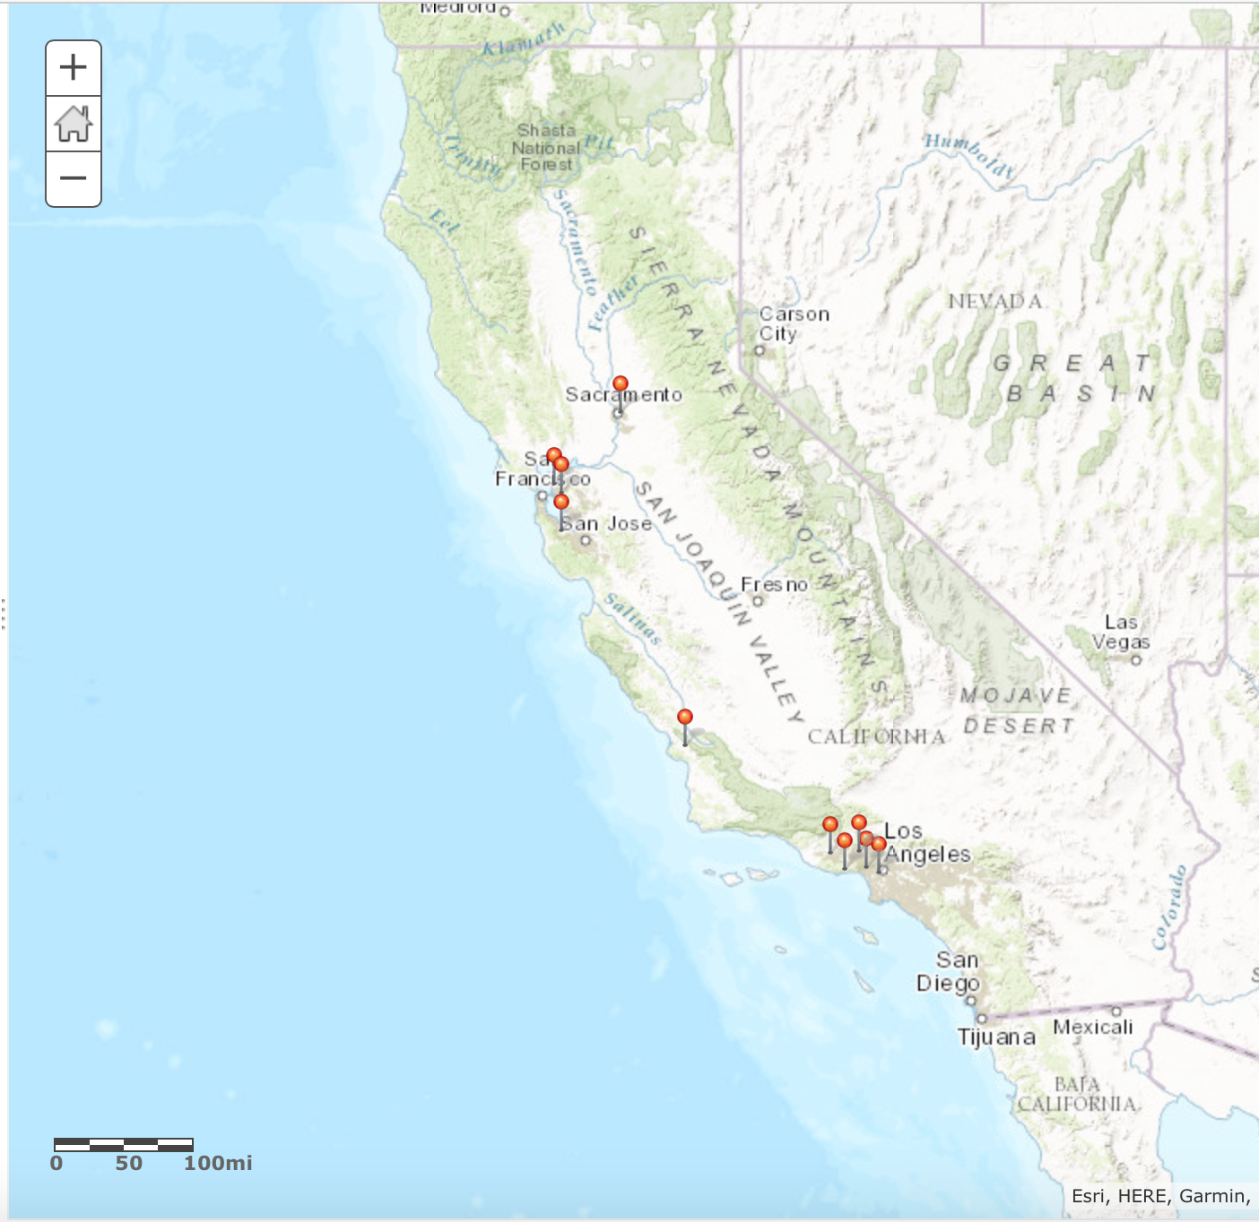

Figure 8: Mapping of Master of Public Policy Programs in California
Strategies for Achieving Objective 2.2

Establish Latino Policy Initiative by Soliciting and Funding Research Projects that Produce Policy Briefs on Issues of Interest to Both Legislators and the Network

In order to serve as the conduit for Latino-focused research across the state, the Network will create a research fund to call for policy briefs, white papers, legislative proposals, and model legislation centered around Latino concerns in the areas of economic development, immigration, education and civic engagement. The Network will initially compile an inventory of existing research as well as research in the process of completion. The Network will offer small grants to researchers in this inventory to draft succinct and user-friendly policy summaries and briefs for use by policy makers and legislators in the state.

In addition to sponsoring research projects, the Network will reach out to law school clinics that undertake policy projects to propose collaborations that produce legislative proposals and model legislation. These project will occur either in conjunction with, or in addition to, the policy briefs produced through the Network’s call for research products.

Timeline: Year 1

Below we detail the month-by-month action items that will help us achieve Objective 2.2 in the first year of the network launch, following submission of this strategic plan.

Month 1 | Communicate with Master of Public Policy Deans and professors; share strategic plan.  Solicit funds from law schools, research partners, foundations, and private donors to establish a Latino Research Fund.
Month 2 | Recruit five Public Policy deans and/or professors and five law school deans and/or professors to participate in our network.
Month 3 | Continue to solicit funds for a Latino Policy Research Fund.
Month 4 | Create and disseminate a call for policy research products for the Latino Policy Research Fund.  Solicit policy projects from community organizations in the network that need assistance.  Reach out to law school clinics to seek interest in collaborations with researchers.
Month 5 | Disseminate call for policy research among Network members and collaborators.
Month 6 | Meet with CLLC members and Network advisory members, and interested law school clinics to choose Research Fund recipients
Month 7 | Distribute Funds. Include community members in distribution, even if nominal.
Months 8-12 | Principals schedule a policy proposal meeting with Latino Policy Research Fund researchers, law school clinics and CLLC

Budget: Year 1

Development of Latino Policy Research Fund $40,000
Dissemination of Call for Latino Policy Research 500
and Distribution of Monies
Latino Policy Research Meeting with CLLC, Sacramento $ 7,000
Travel for researchers $5,000
Lodging for researchers $1,000
Food and Room $1,000
Coordination of Latino Policy Research Fund (5% FTE) $ 7,500

TOTAL $55,000

CORE STRATEGIC GOAL #3: Coordinate Leadership Development

Core Strategic Goal Overview

As part of our larger project, we are committed to developing a pipeline of leadership for the next generation of lawyers, scholars, and policy makers. In this spirit, our third Core Strategic Goal involves developing the infrastructure to support and promote emerging leaders in academia, law and policy, wealth creation, and community organizing. The Network will introduce existing programs to our effort and invite them to share opportunities for apprenticeships, internships, and scholarships created by the Network. The Network’s leadership development efforts will encourage emerging leaders to think beyond what exists and to use new technologies and social networks to think about community problem-solving in new ways.

Objective 3.1 involves the collection and compilation of existing leadership programs that promote leadership development in academia, law and policy, community organizing, and entrepreneurship or wealth creation. Objective 3.2 encourages knowledge-sharing among academics to exchange curricular models, including syllabi, teaching materials, and training models that promote leadership development in Latino communities. Objective 3.3 entails the procurement of funds to establish mid-career and post-graduate fellowships for lawyers, policy makers and researchers, and research assistant positions for students pursuing work that serves the Latino community, either through direct legal service or scholarship.

Figure 6: Schematic of Core Strategic Goal #3
OBJECTIVE 3.1: Database of Leadership Development Resources

Objective 3.1 Overview

Developing and supporting emerging leaders is crucial for the continuing development of the Network. The Network will focus on identifying California-based projects and will also include national programs that are open to Californians to apply. Our goal in conducting this research and producing a database of relevant projects and leadership programs is to assess the landscape of need as well as to draw from existing resources.

Preparedness in Implementing Objective 3.1

In conducting preliminary research following our Network for Justice Summit, we have already identified 26 California-based leadership programs and 14 national programs for which Californians may be eligible to apply. These programs range from day-long leadership events to year-long sustained leadership training where accepted participants are paired with mentors in their respective fields. We have also invited emerging leaders to participate in all of our project events.

Strategies for Achieving Objective 3.1

The Network will invite leaders of the existing programs to participate in a conference call to introduce them to our effort. This conference call will help the Network explain its work and be a resource to a larger group of advocates.

In addition to the conference call, we will develop presentations for the boards of these organizations so a broader group of leaders and prospective collaborators can understand what the Network can offer.

Finally, we will add representatives of these programs to our newsletters, which will include a section on leadership opportunities for emerging and existing leaders.

Timeline: Year 1

Month 1 | Compile descriptions of existing leadership programs in our inventory. Continue research on various programs.
Month 2 | Continue preparing inventory. Develop model survey on leadership development for leadership program to distribute to its participants.
Month 3 | Email executive directors and/or board chairs of these programs to explain our program, share the list compiled, and invite to a conference call.
Month 4 | Hold conference call and request additional names for other programs. Request information about program application dates.
Month 5 | Continue research.
Month 6 | Hold second conference call for individuals representing organizations not previously identified. Request information about program application dates.
Month 7 | Post program information and deadlines on website.
Months 8-12 | Schedule online town hall through for high school seniors, college students, graduate students in relevant fields, and law students about opportunities that are available.

Budget

In addition to the RA request listed under Objective 1.2 above, this goal requires a project manager. It would cost approximately $84,000 to pay for a full-time project manager to coordinate all activities and to serve as a proxy for principals who already have full-time jobs. This figure anticipates that the project manager will be based at an academic institution. Most academic institutions, particularly those that are state-operated, offer generous benefits packages that account for approximately 35-40% of the total salary.

The $84,000 figure therefore anticipates one full-time project manager with the ability to write policy briefings who would earn approximately $60,000 a year plus benefits. In the alternative, the funding can support two part-time project managers with salaries of $30,0000 plus benefits.

OBJECTIVE 3.2: Curricular &
Training Models

Objective 3.2 Overview

It is critical for emerging leaders to understand the history of Latinos in the United States so they are well-informed in mapping out our future. In continuing communication with the Network participants, we will solicit teaching materials, training models, and syllabi to share with a broader audience in the form of a searchable database. We will make materials available online for download by educators at all levels. We hope to use this network to foster an interdisciplinary network of faculty around the country who are focused on how leadership of Latinos in law and policy will shape the future of the United States.

Preparedness in Implementing Objective 3.2

As part of the broader “Future of Latinos” project, we have already compiled an extensive annotated bibliography with over 400 academic and news media sources. We will upload all of these sources and annotations onto the website with links to PDFs so that anyone can access this knowledge. We will continue to update the database as new studies become available. To that end, we will have a “Latest Publications” page, where individuals can upload the most recent articles, books, and chapters related to Latinos and the law. This will be a resource with downloadable articles, reports, and other materials.

Network principals are already connected to an existing law professor network. Through an existing listserv, an annual conference in October, and an annual meeting in January, we can identify individuals in California who are already involved in leadership development efforts at their institution or are interested in creating new venues for leadership development. The Advisory Board of the larger ABF initiative involves academics teaching in public policy schools and other disciplines who can help us connect with individuals teaching courses about and conducting research on the Latino community.

Strategies for Achieving Objective 3.2

The Network will create a repository of materials that faculty and researchers can access. We will begin by sending a request to faculty via various listservs to upload materials onto a Dropbox folder that will be organized by topic and types of materials submitted. This allows faculty to self-select to ensure that we are inclusive of all those who want to participate in leadership development and we are able to think broadly about what leadership in the Latino community needs to include. We will also reach out to those we know have materials but did not upload them.

Once materials are compiled, we will create a directory of institutions that provide leadership development training that are helpful in preparing actual and emerging leaders to tackle the challenges and opportunities of the large and growing Latino population in California. We will inform university presidents, business school deans, law school deans, public policy and urban planning program deans, and other department leaders of these resources and encourage greater support for such training and mentorship of students, faculty, and community leaders.

Through these collective resources, the Network can compile best practices for supporting and encouraging emerging Latino leaders.

Timeline: Year 1

Below we detail the month-by-month action items that will help us achieve Objective 3.2 in the first year of the Network launch, following submission of this strategic plan.

Month 1 | Finalize list of Latino law school and public policy faculty.
Month 2 | Finalize list of legal services and impact litigation leaders to begin solicitation of syllabi, teaching materials, and training models.
Month 3 | Establish Dropbox Folders & send requests to upload. Include student organizations in the request.
Month 4 | Review materials uploaded and determine which ones to promote to the network website launch.
Month 5 | Post materials onto Network website.
Month 6 | Develop best practices for teaching, training, & mentoring leaders in the Latino community. Include op-ed and other media training.
Month 7 | Create a timeline of seminars.
Months 8-10 | Develop content for best practices seminars.
Months 11-12 | Host a seminar each month

Budget: Year 1

See research assistant and project manager requests listed under Objective 1.2 and Objective 3.1, above.
OBJECTIVE 3.3: Fellowship & Research Assistant Funding

Objective 3.3 Overview

To properly develop the pipeline of Latino leaders in academia, law, public policy, economic development, and communities, we must find funding that supports not only research assistant positions and scholarships for students but also post-graduate fellowships for lawyers, policy makers and researchers pursuing work that serves the Latino community.

Post-graduate fellows should work with organizations and institutions that have projects that either challenge existing discriminatory laws or practices that negatively impact the Latino community, or organizations that are working on projects to re-imagine law and policy to positively impact Latinos.

Preparedness in Implementing Objective 3.3

Since May 2015, we have developed a leadership component of our project by training and working with undergraduate students, graduate students, and law school students. To date, we have worked with 10 research assistants from five schools (UC Davis School of Law, UCLA School of Law, Northwestern University, Claremont McKenna College, and Yale School of Law). We embarked on a rigorous fundraising campaign and were able to receive funding to support the work of eight of our research assistants. We have also begun to compile a list of post-graduate fellowships for law students.

Strategies for Achieving Objective 3.3

We will coordinate with existing organizations to host regional meetings in Northern California for young and emerging leaders to brainstorm ideas for projects and provide feedback on post-graduate fellowship applications. We will enlist Latinos and Latinas who have been recipients of post-graduate fellowships to share their experiences.

In addition, we will create four research assistant positions to work with faculty at UCLA and UC Davis on the Network for Justice. We are choosing UCLA and UC Davis as sites to base this work because the Network has obtained the most support from these institutions and because Network principals are based there. Also, we want to be sure that the Network has a presence in both parts of the state and that the bases represent urban and rural communities that have the most access to resources that support this project.

Finally, we will obtain a commitment from UC law school deans for four post-graduate fellowships for students working on issues to advance Latino civil and legal rights.

Timeline: Year 1

Month 1 | Research post-graduate fellowship opportunities.
Month 2 | Identify key organizations and institutions from the Network to host post-graduate fellows and establish meetings with their directors. Identify relevant post-graduate fellowship opportunities.
Month 3 | Meet with directors to discuss possible projects for post-graduate fellows.
Month 4 | Send letter to law school, public policy school, business school, and social science department lead administrators to describe project and post-graduate fellowship opportunities. Send similar letter to foundations.
Month 5 | Meet with university, law school, public policy school, and business school leaders to discuss possibilities of post-graduate fellowships.
Month 6 | Submit foundation proposals. Include funding to incorporate community voices.
Month 7 | Prepare for regional brainstorming and fellowship-preparation meetings.
Months 8-12 | Hold regional brainstorming and fellowship-preparation meetings.

Budget: Year 1

See Objective 1.2 budget for RA budget
Travel to meet with academic and foundation leaders $10,000
Conference Budget – Food & Conference Coordinator $25,000

In addition the Network would seek funding to fund four post-graduate
fellowships at $60,000 per year.
Post Graduate Fellowships ($60,000 x 4) $240,000

CONCLUSION

In this document we have outlined a cohesive plan to launch our Network for Justice project in California. While we anticipate it will take approximately a year to launch the Network, the plan outlines specific activities that we could undertake in the first year of the launch. The present strategic plan will enable us to launch an unprecedented Network for Justice in California that will directly aid members of the Latino community who experience limited access to justice. Thirty percent of the 15 million Latinos in California live in poverty, the highest rate for any racial or ethnic group in the state. Several studies have shown that these individuals enter the legal system with little or no formal representation. This network will enable the stakeholders to leverage existing resources and expand capacity to better serve this significant and growing population. Any successful litigation or legislation influenced by the network has the potential to positively affect the lives of Latinos across the state and the nation.

Our network will assist advocacy organizations to bridge the gap between their limited resources and the ever-increasing demand for services. Through the network, community advocates will be able to reach out directly to clinicians and lawyers as they seek assistance for their constituents. Our clinical network will continue this tradition of providing opportunities to emerging social justice leaders by offering fellowship opportunities for emerging leaders. A recent study at Stanford Law School found there is little institutional support for the increasing number of students who are interested in public service careers. Our network will provide the necessary knowledge, skills, and mentoring to enable students to pursue social justice work for Latinos. We plan to create a pipeline to public service in which CBF scholarship and fellowship recipients, among others, will have access to clinical opportunities and training that may not otherwise exist. The practicing bar will use this network to identify where pro bono resources might best be directed, and foundations will be able to ascertain critical areas of investment to improve the quality of life for Latinos.

Below is a project budget for launching the Network. It is broken down by specific goal to encourage funders and academic institutions to commit to all of the project or parts of it.

Network for Justice: California Launch Budget

Core Strategic Goal #1
 | Objective 1.1 | $ 25,000
 | Objective 1.2 | $ 50,000
Total CSG #1 |  | $ 70,000
Core Strategic Goal #2
 | Objective 2.1 | $ 2,500
 | Objective 2.2 | $ 55,000
Total CSG #2 |  | $ 57,500
Core Strategic Goal #3
 | Objective 3.1 | $ 84,000
 | Objective 3.2 | N/A
 | Objective 3.3 | $35,000  $ 240,000
Total CSG #3 |  | $ 375,000
Total Project Budget |  | $ 491,500

After we have successfully piloted the Network for Justice in California, we plan to expand it nationally. We anticipate that our Network for Justice will influence law and policy throughout all levels of government. We hope that our clinical network can be used as a model for other communities that experience gaps in the delivery of legal services and social justice.

See Mark Hugo Lopez, Rich Morin, & Jens Manuel Krogstad, Latinos Increasingly Confident in Personal Finances, See Better Economic Times Ahead, Pew Research Center (June 8, 2016), http://www.pewhispanic.org/2016/06/08/latinos-increasingly-confident-in-personal-finances-see-better-economic-times-ahead/.
See Annette Bernhardt et al., Broken Laws, Unprotected Workers: Violations of Employment and Labor Laws in America, (2008), http://nelp.3cdn.net/1797b93dd1ccdf9e7d_sdm6bc50n.pdf.
See Columbia Law School Human Rights Institute & Northeastern University School of Law Program on Human Rights and the Global Economy, Equal Access to Justice: Ensuring Meaningful Access to Counsel In Civil Cases, Including Immigration Proceedings (2014), http://web.law.columbia.edu/sites/default/files/microsites/human-rights-institute/files/equal_access_to_justice_-_cerd_shadow_report.pdf.
See Barry J. McMillion, Number of Hispanic U.S. Circuit and District Court Judges: Overview and Analysis, CRS Oversight (Oct. 15, 2015), https://fas.org/sgp/crs/misc/IN10373.pdf.
See ibid.
See Maria Chavez, Everyday Injustice: Latino Professionals and Racism 178 tbl.3.2 (2011).
See Maria Chavez, Everyday Injustice: Latino Professionals and Racism 178 tbl.3.2 (2011). See Latino Elected Officials in America, Naleo, http://www.naleo.org/at_a_glance (last visited Apr. 2, 2017).
See Seth Motel & Eileen Patten, The 10 Largest Hispanic Origin Groups: Characteristics, Rankings, Top Counties, Pew Research Center (July 12, 2012), http://www.pewhispanic.org/files/2012/06/The-10-Largest-Hispanic-Origin-Groups.pdf.
To access the 2014 Imperial county Agricultural Crop & Livestock Report, please visit http://www.co.imperial.ca.us/ag/crop_&_livestock_reports/2014%20Crop%20and%20Livestock%20Report.pdf.
One of the earliest recorded strikes of farmworkers occurred on January 1, 1930, when over 5,000 Mexican and Filipino lettuce workers walked off the job. See Kate Bronfenbrenner, Imperial Valley, California, Farmworkers’ Strike of 1930, Cornell University, ILR School (1990), http://digitalcommons.ilr.cornell.edu/cgi/viewcontent.cgi?article=1562&context=articles.
See generally Farmworker Justice Poder Sano, Directory of Organizations that Serve Rural Latino Communities, Farmworkerjustice.org (Apr. 5, 2017, 12:23 pm), https://www.farmworkerjustice.org/sites/default/files/Compendium%20%205%20states%20final.pdf.
José Padilla, Lawyering Against Power: the Risks of Representing Vulnerable and Unpopular Communities, 11 Seattle J. for Soc. Just., 173, 184 (2012) (describing CRLA’s constant political attacks).
The Caucus is comprised of five Senators, twenty two assembly members, and two state constitutional officers. See California Legislative Law Caucus, A Historical Overview of the California Latino Legislative Caucus, latinocaucus.legislature.ca.gov (Apr. 5, 2017, 1:58 pm), http://latinocaucus.legislature.ca.gov/our-story.
California Latino Legislative Caucus, Policy Priorities, latinocaucus.legislature.ca.gov (Apr. 5, 2017, 1:59 pm), http://latinocaucus.legislature.ca.gov/policy-priorities.
California Latino Legislative Caucus, Research/Reports, latinocaucus.legislature.ca.gov (Apr. 5, 2017, 2:04 pm), http://latinocaucus.legislature.ca.gov/reports-research.
See Foundation Center and Hispanics in Philanthropy, Foundation Funding for Hispanics/Latinos in the United States and for Latin America , scpr.org (Apr. 29, 2017, 7:39 pm), http://media.scpr.org/documents/2012/04/27/HIP_FoundationCenter_Report_Latino_Funding_2011_revMar30.pdf
Jeffrey M. Humphreys, 2016 Multicultural Economy, Selig Center for Economic Growth (2017).
See generally California Public Utilities Commission, Advanced Services Fund: A program to bridge the digital divide in California, cpcu.ca.gov (Apr. 5, 2017, 2:09 pm), http://www.cpuc.ca.gov/uploadedFiles/CPUC_Public_Website/Content/Utilities_and_Industries/Communications_-_Telecommunications_and_Broadband/Reports_and_Presentations/CASF 2015 Annual Report%281%29.pdf.
See generally Anna Brown et al., Digital Divide Narrows for Latinos as More Spanish Speakers and Immigrants Go Online, pewhispanic.org (Apr. 5, 2017, 2:14 pm), http://www.pewhispanic.org/2016/07/20/digital-divide-narrows-for-latinos-as-more-spanish-speakers-and-immigrants-go-online/.
One of these models is the Southern Immigrant Freedom Initiative initiated by the Southern Poverty Law Center, large law firms, AILA and the Innovation Law Lab (a tech-based immigration-related cloud-based legal services provider). Together, all of these parties have agreed to take on immigrant detainee representation in one detention center in Lumpkin, Georgia. This is the type of initiative that brings all of the players together in a way that each has an important stand-alone part and is not depending on any other for specific support or leadership.
National Council of La Raza, Find Affiliates in Your Area, nclr.org (Apr. 5, 2017, 2:18 pm), http://www.nclr.org/affiliates/search/. As of July 10, 2017, NCLR changed its name to UnidosUS.
Immigration Advocates Network, National Immigration Legal Services Directory, immigrationadvocates.org (Apr. 5, 2017, 2:20 pm), https://www.immigrationadvocates.org/nonprofit/legaldirectory/.
California Latino Legislative Caucus, supra, note 14.

